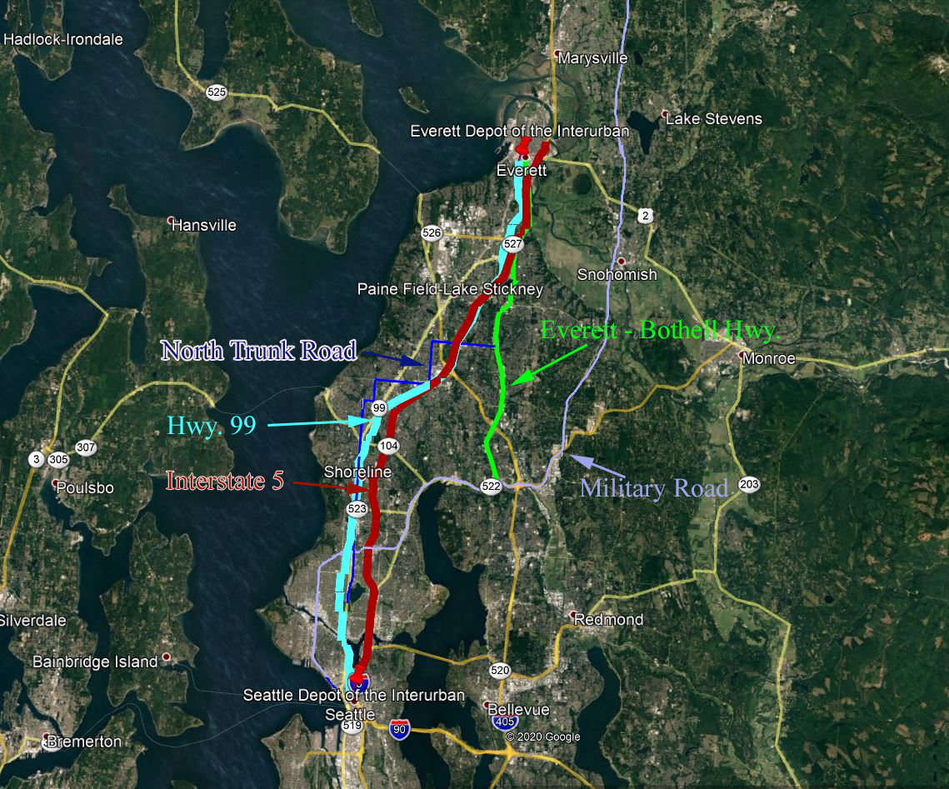

Time Line of Road Construction in the Seattle/Everett vicinity.

1. 1858 to 1864 : the Military Road was surveyed and constructed connected Fort Wancouver to Fort Bellingham.
2. 1880s: Aurora Highway, the very southern part of what later becam the North Truck Road System, was a crude wagon road as far north as to what is now the Evergreen – Washelli Cemetery.
3. 1910: the Interurban started providing service between Seattle and Everett for both passengers and freight, with a stop at the Martha Lake Station.
4. 1912: The North Truck Road was extended to the King-Snohomish County line.
5. 1915: A cut-across road was built from what is now the intersection of Highway 99 and Highway 104, the old Aurora Mall location down to Edmonds.
6. 1916: The Everett Bothell Highway was constructed. It became part of Highway 99 in 1926, but in 1927, the more direct and current route of Highway 99 was completed.
7. 1925: The City of Edmonds extended Main Street in Edmonds to Five Corners to a more northerly tie into the North Truck Road.